REPORT ON PERSONAL FINANCE TRACKER
BY S.LAVANYA

TRAINER
ELAVTORS
CREATING SCHEMA:
Creating table for user:
- CREATE TABLE users (user_id INTEGER PRIMARY KEY,name TEXT);
Creating table for income:
- CREATE TABLE income (inc_id INTEGER PRIMARY KEY,user_id INTEGER REFERENCES users (user_id),amount NUMERIC,received_date NUMERIC);
Creating table for expenses:
- CREATE TABLE expenses (exp_id INTEGER PRIMARY KEY,user_id INTEGER REFERENCES users (user_id),amount NUMERIC,cat_id INTEGER REFERENCES categories (cat_id),spend_date NUMERIC);
Creating table for catagories:
- CREATE TABLE categories (cat_id INTEGER PRIMARY KEY,cat_name TEXT);

Insert values into tables users,income,expenses,catagories

Queries for summarising expenses monthly

- select strftime('%y-%m',spend_date)as month,sum(amount) as total_spent from expenses group by month;

output: expenses monthly
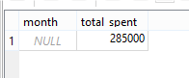
Qureies for categories wise spending using group by command

- select u.name,c.cat_name,sum(e.amount) from expenses e join users u on e.user_id=u.user_id join categories c on e.cat_id=c.cat_id group by u.name,c.cat_name;
output for catagories wise spendings:
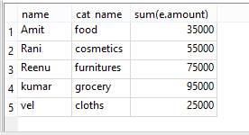
Creating a view for balance tracking
- select u.name,(select sum(amount) from income where user_id=u.user_id)-(select sum(amount) from expenses where user_id=u.user_id)from users u

THANK YOU

